Roden School Council Meeting Minutes
Meeting Held 7:15pm – 9pm in Roden School Library

Attendance
- Jodi, Cathy, Kristen, Mike, Rhonda, Jen, Kitty, Dana, Wendy, Kelda, Natalie, Lindsay, Paula, Tawnya, Dasha

Principal’s Report
- UNION ACTION
  - Cathy receives information at the same time as the general public
  - Can’t provide more updates with regards to duration or future strike days
- YTV – MUSICAL UPDATE
  - Will be coming on Feb 19 (maybe 17) date to confirmed with Cathy
  - They are coming to work with kids who are working on the musical
  - Although teachers unable to work on the musical even during school hours now, Cathy is still working with the musical dance group
  - YTV will interview students about climate change, Radioactive Spider the musical
  - The students will perform either plastic man or don’t bug me
  - YTV will teach them a song and/or dance
  - NOTE: the dance group practices on Monday or Wednesday and is comprised of grades 2-5 students. Parents are welcome to come watch.
  - Even if the musical isn’t able to progress (union action), there WILL be an assembly at least to see the dances that the students have been working on.
- STUDENT SUCCESS FUNDS
  - Cathy has secured $7000 from the board for creating some initiative within the school.
  - Previously teachers had created a bunch of electives (Grade 7 & 8) that were shared between Equinox and Roden
  - This year the decision is to be STEM focused. Curriculum is being written for the interactive sand table upstairs that will be for grades JK-8.
  - Also covers workshops with teachers (assuming that strike action stops)
  - Thelma and Kyle are also working with Dan on coding projects for older grades
- CULTURAL EVENTS
  - These are all still a go. Dates confirmed and booked:
  - Feb 27 - Ballet Creole
  - March 5 - Explain the Impossible – Illusionist
  - April 23 – Orchestra
- GENDER BASED VIOLENCE - TDSB department (has been cut)
  - Coming in on February 26 to do workshops with Grade 6 on safe use of technology
  - Cathy reached out because 4 girls were approached by an 80-year old gentleman OFF school grounds which made them feel uncomfortable and they told Cathy about it.
  - Cathy confirmed with parents that she could speak to the girls and the police.
  - Police officer was excellent, it appeared the man would come out and say hello to all the kids leaving school, since being spoken to by the police he’s stopped.
  - FOLLOW UP: Cathy is looking to have other groups come in and speak with the grades 4&5s and 7&8s.
- CHRIS RETIREMENT (VP)
  - Doing an event either the last day or second last day of the school year. TBD.
  - Students are learning a few songs and music to accompany them.
  - Sherman doing a video/slideshow
  - Susanna to present him with something
- HANNA’S SUITCASE - BOOK
  - There was a webcast on Jan 27
  - Cathy is reaching out to see if the author might come the first week of April to speak to the grade 6-8s
- VACCINATION RATES
  - Jodi & Cathy both did some research with Public Health records
  - Currently Health Canada statistics shown in the multiple articles as 22% unvaccinated. Upon comparing recorded vaccines of older siblings reported to public health, they’d estimate 2% of Equinox has the exemption for vaccination.
  - Roden receives an update for Public Health 2-3 times a year with regards to missing vaccines
  - Lindsay mentioned: CanImmunize: will automatically send your vaccine information to Toronto Public Health and send reminders when new vaccines are due

Decisions
- UNION ACTION – SCHOOL COUNCIL TO SUPPORT TEACHER POSITION
  - Vote held, 8 voted in favour (unanimous).
  - School council to send a letter to Premier, MPP, Minister of Education in support of teacher position.
  - Council to advertise strike days and our support of the teachers.
    - Open it up for comments about local businesses running legit (licensed) STRIKE camps.
  - Feb 6 & 11 teacher’s picketing downtown
  - Feb 7 & 12 teacher’s picketing at Roden
  - Jen shared the appreciation of teachers for all items (food, hand warmers) dropped off while they were striking. Susanna made soup.
- PRO (Parent’s Reaching Out) Grant Update – SCHOOL COUNCIL TO SEND LETTER TO BOARD AGAINST CHANGES
  - Previous process was to apply and receive $1000 to link parents to the school
  - CHANGE: Allocation based funding model and TDSB has been given the following:
    - $103K - Ward engagement.
    - $30K Parent’s as Partners Conference (TCC)
    - Details at the end of the meeting notes.
- DANCE-A-THON – FRIDAY MARCH 13^{th -} ALLOCATION FOR MUSIC iPADS
  - Good to go ahead assuming the school is open
  - To ease collection, Grades 1- 8 will have buckets in the classroom to drop money
  - Kindergarteners will be collected by a parent volunteer: Wed - Fri
  - Envelopes sorted out already
  - Raises $2000 - $3000 on average
- CLOTHING/TOY SWAP – NO DATE DETERMINED YET
  - LEAD: Wendy
  - Liase with Andrew to pick a date
  - TEAM: Kitty, Andrea
  - NOTE: Wendy will be putting the lost and found items that are not claimed into the swap
- ART AUCTION – CANCELLED FOR 2019-2020
  - Lead: Gisele offered to organize it
  - REQUEST: need new people to help volunteer to run the logistics for it
  - Likely to be end of May or the beginning of June
  - Usually the artists know a few months in advance so that they could do it in April/May
- CLASSROOM BUDGET INCREASE – FUNDS ALLOCATED TO SPECIALITY TEACHERS
  - VOTE: 8 voted in favour.
  - Increase of $400 - this will come from the FLIPGIVE money
  - Funds to go towards: Music teachers, Special Education, and French.
- SPRING CONCERT/BAKE SALE – FUNDS ALLOCATED TO STAFF APPRECIATION
  - Vote held, 8 voted in favour.
  - Staff appreciation to consist of: Hot lunch, gift card, glue sticks, etc.
- FUN FAIR – FUNDS ALLOCATED TO 2020-2021 CULTURAL EVENTS
  - Vote held, 8 voted in favour.

General Business
- PARENT CONCERN REGARDING PLAY FIGHTING / FIGHTING IN SCHOOL
  - Discussion at the social last week
  - Seems to be primarily Grade 2 –5 boys. Suggestions on how Grades 6-8 leave school grounds so having them volunteer to help supervise wouldn’t be possible.
  - Cathy sees this happening typically between Grade 2-5 boys. Tend to be started because of playing and competition leads to violence
    - Bump escalates to push to fight
  - Kids unable to regulate themselves
    - Discussion if OPAL - Outdoor education program that is running at Blake is an option for Roden
- EVENT UPDATES:
  - Natalie: Biggest concert bake sale EVER!!! $1500 - STEAM
  - Silent Auction: Nearly $3000 - STEM
  - Movie Night: Raised $700. Used new tickets that allowed for some free ticket entry which worked really well
    - March 27th - allocated to the Grade 8s
    - May 1st - not yet allocated
  - Parent/Caregiver Social: 20 people were out. Very limited setup with Chris at Eulelie’s
    - Encourage people to bring a friend who didn’t come last time
    - Create a new poster with the different dates coming up
    - Last Wednesday of the month going forward
    - Next Date: February 25th
- NEW INITIATIVE FOR 2020-2021
  - Need to start planning in May/June for
  - Example; previous years there’s been a Walk-a-thon held in September had Canadian Tire sponsorship. No decision on moving this forward.

Finances
- CLASS BUDGET INCREASE
  - Jen has already made the purchases
  - All teachers have provided their list. Orders have all been placed
  - Teachers are excited and eager to have the time.
    - Pillows, Microscope, Robot building kits, filing units, bins, books, etc.
  - $600 as their annual classroom budget, so $100/class was a big deal.
- WATER FOUNTAIN
  - It does NOT filter the water, and we’d have to pay ongoing.
  - Vote held, 8 voted in favour.
  - Increase budget to $2800 FROM the original allocation of $2500.
  - To be installed on main floor near girl’s change room.
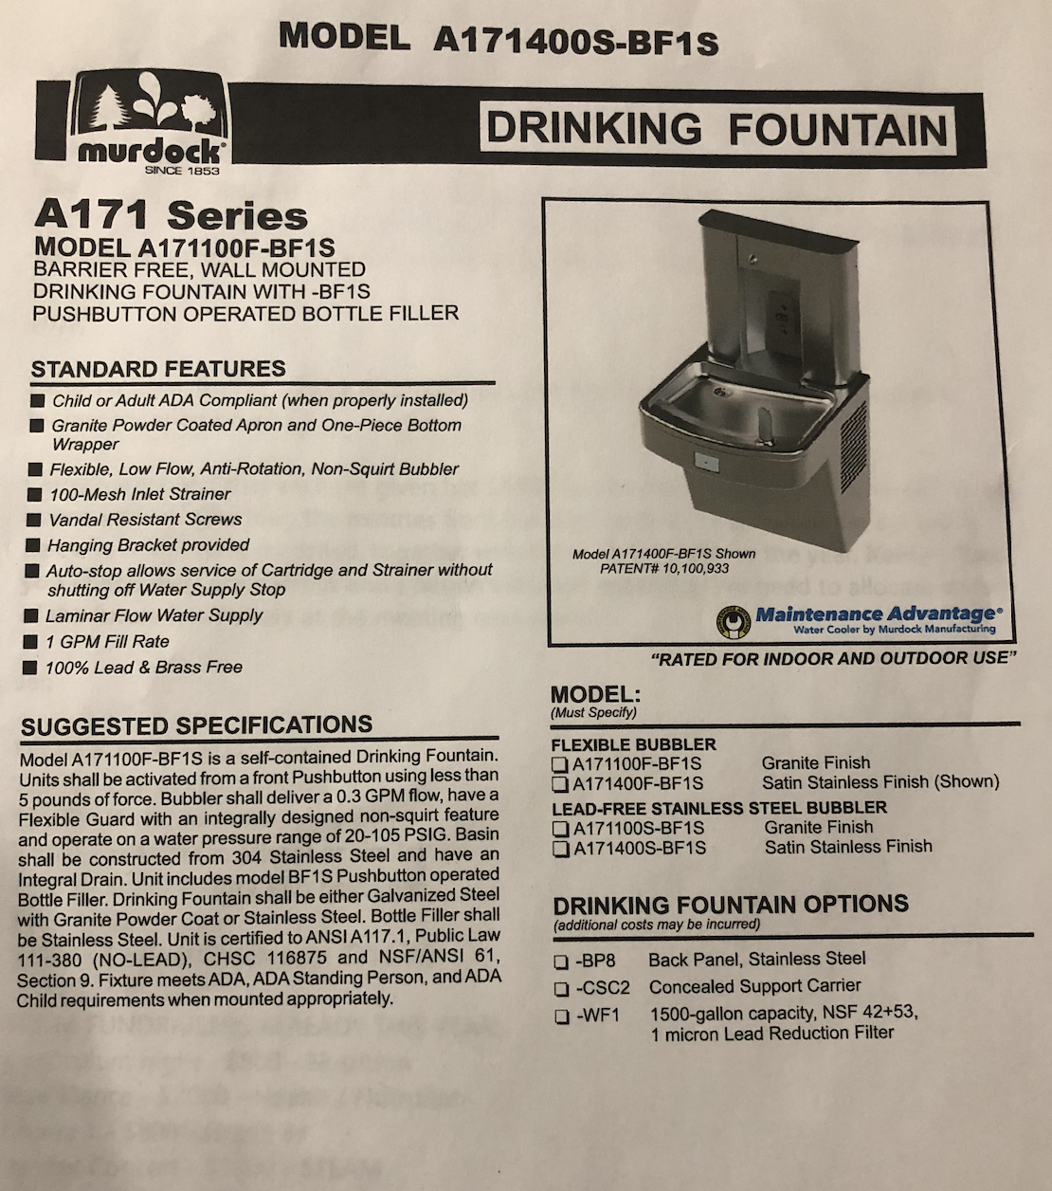
- MUSCIAL
  - Request for $1000
  - Currently have 12 Roden dancers and 6 Rodent students (50/50 split between Roden and Equinox
  - Space has been rented in the Distillery for the performance

Follow Ups
- JEN: school council to do a dance/song at Chris’ retirement need to confirm with Cathy
- LINDSAY: send Jen the information for the Canimmunize website – DONE
- MIKE: write letter on behalf of school council to Premier in support of teacher unions based on template already in use
- JEN: write letter to state council’s dislike of the new allocation funding model for PRO
- MIKE: confirm next parent social date with Chris as Eulelie’s
- MIKE: to provide posters for parent social for photocopying/posting
- TAWNYA: coordinate sending email with Stephanie and Jodi to Roden/Equinox parents regarding social
- CHARLIE: to confirm process for renewing the movie subscription and that it’s been done. Cathy has confirmed they will split the costs.
- JEN/KRISTEN: follow up with Giselle to collect information about the art auction logistics to have for next year – DONE
- DANA: Email Shelly to find out the rain check policy for the DJ for the upcoming dance-a-thon. Based on this, coordinate with Cathy if we decide to push this to April/May.
- KITTY/DANA/WENDY: To be the parent volunteers to collect the kindergarten dance-a-thon money

2019/2020 Parent Reaching Out Grant (PRO Grant) Allocation
The PRO Grant program provides funding to district school boards and school authorities to lead projects with a focus on the identification and removal of barriers that prevent parents and families from participating and from engaging fully in their children’s learning.
The Ministry changed the program from an application-based funding model to an allocation-based grant provided to each school board. School boards received a predetermined funding amount for parent engagement projects.
TDSB was allocated $133, 405.35 for projects that demonstrate a commitment to respecting the role of parents in students’ educational experiences. All funds must be spent and reported to the Ministry by June 15, 2020.
The Board, at its meeting on November 27, 2019 approved the allocation of $133, 405.35 to the following areas:
Learning Network / Centre & Ward Engagement ($103,405.35)
Learning Centre Executive Superintendents will consult with Superintendents of Education, Trustees and the Parent Involvement Advisory Committee Representatives to identify initiatives that fall within the following areas:
- Supporting and enhancing school council capacity
- Enhancing the efficiacy of families around mental health and wellbeing, equity or achievement and/or
- Engagement of diverse families and school councils in the School Improvement Process (e.g. workshops/training for families)
2020 Parents as Partners (PAP) Conference ($30,000)
PAP is scheduled for Saturday, March 28, 2020 and will run from 8:30 a.m. to 3:30 p.m. at The Toronto Congress Centre. The day will offer families/guardians the opportunity to participate in day long learning, sharing and networking with families, staff and community partners. The day will feature a keynote address, informative workshops and a vendors’ marketplace of local associations and agencies which provide many different kinds of support for children and families.
For further information on Learning Centre and Ward engagement initiatives, please visit: Parent Reaching Out Grants (PRO Grants)
For information on the Parent as Partners Conference, please visit: parentsaspartners.ca Should you require additional information, please contact Colleen Russell-Rawlins, Assocaite Director of Equity, Well-Being and School Improvement at colleen.russell-rawlins@tdsb.on.ca or Michelle Munroe, Central Coordinator of Parent and Community Engagement @ michelle.munroe@tdsb.on.ca

